AD POSTING WEBSITE FOR BUYER-SELLER INTERACTION OVER PURCHASE OF USED PRODUCTS

### A project report submitted to the in partial fulfilment of the requirements for the award of the degree of

**BACHELOR OF TECHNOLOGY IN**

**COMPUTER SCIENCE AND ENGINEERING**

#### Submitted By

Ch.Yasaswini (18071A0509)

K.Vaishnavi (18071A0524)

CH L S N S D Likhita (18071A0565)

#### Under the Guidance Of

#### Mrs.N.Lakshmi Kalyani

**(**Assistant Professor, VNRVJIET)



**COMPUTER SCIENCE AND ENGINEERING DEPARTMENT**

#### VNR VIGNANA JYOTHI INSTITUTE OF ENGINEERING AND TECHNOLOGY

(An Autonomous Institute, NAAC Accredited With ‘A++’ Grade, NBA Accredited, Approved by AICTE, New Delhi, Affiliated to JNTUH)

I

**VALLURUPALLI NAGESWARA RAO VIGNANA JYOTHI INSTITUTE OF ENGINEERING AND TECHNOLOGY**

(An Autonomous Institute)

#### Hyderabad-500090



**CERTIFICATE**

This is to certify that **Ch.Yasaswini (18071A0509), K. Vaishnavi (18071A0524), CH.L.S.N.S.D.Likhita (18071A0565),** have successfully completed their project work at CSE Department of VNR VJIET, Hyderabad entitled **“AD POSTING WEBSITE FOR BUYER-SELLER INTERACTION OVER PURCHASE OF USED PRODUCTS ”**in partial fulfilment of the requirements for the award of B. Tech degree during the academic year 2019-2020.

Project Guide Head of the Department

#### Mrs.N.Lakshmi Kalyani Mrs. B. V. Kiranmayee

Assistant Professor Associate Professor & Department of CSE Head of the Department CSE

VNR VJIET VNR VJIET

II

# DECLARATION

## This is to certify that the project work entitled **“AD POSTING WEBSITE FOR BUYER-SELLER INTERACTION OVER PURCHASE OF USED PRODUCTS”** submitted in VNR Vignana Jyothi Institute of Engineering & Technology in partial fulfilment of requirement for the award of Bachelor of Technology in Computer Science and Engineering is a bonafide report of the work carried out by us under the guidance and supervision of Mrs.N.Lakshmi Kalyani (Assistant Professor), Department of CSE, VNRVJIET. To the best of our knowledge, this report has not been submitted in any form to any university or institution for the award of any degree or diploma.

III

|  |  |  |
| --- | --- | --- |
| **Ch.Yasaswini** | **K.Vaishnavi** | **CH L S N S D Likhita** |
| (18071A0509) | (18071A0524) | (18071A0565) |
| I I B.Tech-CSE, | I I B.Tech-CSE, | I I B.Tech-CSE, |
| VNR VJIET | VNR VJIET | VNR VJIET |

**ACKNOWLEDGEMENT**

## Behind every achievement lies an unfathomable sea of gratitude to those who activated it, without it would ever never have come into existence. To them we lay the words of gratitude imprinting within us.

We are indebted to our venerable principal **Dr. C. D. Naidu** for this unflinching devotion, which lead us to complete this project. The support, encouragement given by him and his motivation lead us to complete this project.

We express our thanks to internal guide **Mrs.N.Lakshmi Kalyani** and also Head of the department **Mrs. B. V. Kiranmayee** for having provided us a lot of facilities to undertake the project work and guide us to complete the project.

We express our sincere thanks to our faculty of the department of **Computer Science and Engineering** and the remaining members of our college **VNR VIGNANA JYOTHI INSTITUTE OF ENGINEERING**

## **AND TECHNOLOGY** who extended their valuable support in helping us to complete the project in time.

Ch.Yasaswini (18071A0509)

K.Vaishnavi (18071A0524)

CH L S N S D Likhita(18071A0565)

IV

**ABSTRACT**

Our main focus is on the student community, because it is limited to college or of any organization and by which there is very less chance of frauds to take place. Users who want to sell or buy products must firstly sign up using their roll number, email id, password, phone number. For the persons who want to sell the products, they need to log in to their accounts and they need to fill the form by providing the details of the product they want to sell such as product title, product category, product description, image of the product, price of the product etc. and then this product will be visible on that particular category page of the website. Buyers can search for a product by category and the list of related items will be displayed and they can choose the product they want to buy by clicking on the buy button present there. Any user can add his/her favourite products to ‘My favourites’ . After pressing the buy button, a request will be sent to that product- seller that someone wants to contact you regarding your product. The buyer can also view the request in his/her request page and can withdraw the request at any point of time. Similarly, the seller can accept/decline the request. Buyer can interact and bargain with the seller using the WhatsApp chat option available in that particular product details page. If the seller clicks on accept, the product will be removed from the database. All the sold and bought products will be visible in their respective dashboards in Items sold and orders. Any club of the organization can post their events by filling an event registration form which can be accessed only by the club heads. All the event details are visible on the Events Page.

V

#### INDEX

Contents Page. No

CHAPTER 1: INTRODUCTION 1

* 1. Introduction to Web development 1
  2. Objectives 2
  3. Work Environment 3

CHAPTER 2: LITERATURE SURVEY 4

* 1. Web Technologies 4
     1. HTML5 4
     2. CSS 5
     3. Bootstrap 6
     4. Java Script 7
     5. jQuery 7
     6. Font Awesome 8
     7. Google Maps 9
     8. Google Fonts 9
     9. Get Button 9

2.1.10 Django 10

CHAPTER 3: EXISTING AND PROPOSED SYSTEM 11

* 1. Existing System 11
     1. Limitations 11
  2. Proposed System 12

CHAPTER 4: SYSTEM ANALYSIS 13

* 1. System Requirements 13

VI

* + 1. Software Requirements 13

4.1.1.1 Python 13

4.1.1.2 Command Prompt 14

4.1.1.3 Virtual Env 14

4.1.1.4 Django 14

4.1.1.5 VSC 15

4.1.1.6 Pillow 15

4.1.1.7 Passlib.hash 15

4.1.1.8 Postgresql 16

4.1.1.9 pgAdmin 17

4.1.1.10 Psycopg2 17

* + 1. Hardware Requirements 18

CHAPTER 5: SOFTWARE DESIGN 19

* 1. UML Diagrams 19
     1. Use case Diagram 20
     2. Class Diagram 21
     3. Sequence Diagram 23
     4. Activity Diagram 24

CHAPTER 6: IMPLEMENTATION 27

* 1. Code 27
     1. Setting up Virual env & Installing Django 27
     2. Starting Project and Apps 28
     3. Project folders “

6.1.3.1 urls.py 30

VII

6.1.3.2 Templates folder 31

6.1.3.3 views.py 34

6.1.3.4 models.py 35

6.1.3.5 Links 35

* 1. Performed Tasks 36
     1. Home Page 36
     2. About Page 38
     3. Products Page 39
     4. Events Page 40
     5. My Favourites Page 41
     6. User Dashboard 41

6.2.6.1 My Profile 42

6.2.6.2 Requests 43

6.2.6.3 Orders Page 43

6.2.6.4Items Sold 44

6.2.7 Sell form 44

6.2.8 Event Registration Form 45

6.2.9 Sign Up Page 45

6.2.10 Login Page 46

CHAPTER 7: TESTING 47

* 1. Testing plan 47
     1. Test Data 47
     2. Testing Methods 47

7.1.2.1 Blackbox Testing 47

7.1.2.2 White Box Testing 48

* + 1. Unit Testing 48

VIII

* + 1. Test Report 49
    2. Error Report 49

CHAPTER 8: CONCLUSION 50

* 1. Conclusion 50
  2. Future scope 50

CHAPTER 9: BIBILOGRAPHY/REFERENCES 51

9.1 References 51

IX

# LIST OF FIGURES

Contents Page.No

# List of Figures

Fig 4.1: Python 13

Fig 4.2: Django 14

Fig 4.3: Visual Studio Code 15

Fig 4.4: PostgreSQL 16

Fig 4.5: pgAdmin4 17

Fig 5.1 Use Case Diagram for Developed Model 20

Fig 5.2 Class Diagram for Developed Model 21

Fig 5.3: Sequence diagram for User Registration 23

Fig 5.4: Sequence diagram for Seller Registration 24

Fig 5.5: Activity Diagram 26

Fig 7.1 Blackbox Testing 48

Fig 7.2: White box Testing 48

X

# CHAPTER - 1

# INTRODUCTION

# 1.1 Introduction to Web development

Web development refers to building, creating, and an maintaining websites. It includes aspects such as [web design](https://techterms.com/definition/web_design), [web publishing](https://techterms.com/definition/web_publishing), web programming, and [database](https://techterms.com/definition/database) management. While the terms "web developer" and "web designer" are often used synonymously, they do not mean the same thing. Technically, a web designer only designs website interfaces using [HTML](https://techterms.com/definition/html) and [CSS](https://techterms.com/definition/css). A web developer may be involved in designing a website, but may also write web [scripts](https://techterms.com/definition/script) in languages such as [PHP](https://techterms.com/definition/php) and [ASP](https://techterms.com/definition/asp). Additionally, a web developer may help maintain and update a database used by a [dynamic website](https://techterms.com/definition/dynamicwebsite).

Web development includes many types of web content creation. Some examples include hand coding web pages in a [text editor](https://techterms.com/definition/texteditor), building a website in a program like Dreamweaver, and updating a [blog](https://techterms.com/definition/blog) via a blogging website . These tools make it easy for anyone to create and edit their own website using a web-based [interface](https://techterms.com/definition/interface). Most large businesses do not use content management systems, but instead have a dedicated Web development team that designs and maintains the company's website(s).

Web development may be a collaborative effort between departments rather than the domain of a designated department. There are three kinds of Web developer specialization: front-end developer, back-end developer, and full-stack developer. Front-end developers are responsible for behavior and visuals that run in the user browser, while back-end developers deal with the servers.

* 1. **Objectives**

Web development is to handle the entire activity of a website. The software keeps track of all the information about the entire website. The system contains database where all the information will be stored safely.

1

### a) To reduce the number of workers

After the system will be computerized only a single computer operator will be needed to operate the system while now more than one workers work in the system.

### b) To reduce the space being used

Every data will be stored in the computer memory whereas now it is stored in registers and files which then stored in bookshelves or cupboards and they need a large space.

### c) To reduce the work load

As the new system will be computerized, the database will be automatically updated at the time of entry. Everything will be done automatically just by clicking few buttons. There will be no need to maintain any files or registers.

### d) To make it easy to search any record

It will be much easier to find particular record rather than opening such huge files and finding a single record from them

### e) To edit records and update the database easily

Records will be easily edited and the database will easily be updated at the time of entering a record.

### f) To make the system user friendly

The system will be much more easy to use and the operator will feel no difficulty.

## **Work Environment**

**Front end Developer** The front end developer generally works at client side dealing with the web page design, graphics that is accessible to the user.

2

**Back end Developer** The back end developer is a person who is responsible for the back end development that interacts with the server. This type of web developer specializes in the languages like Python , PHP, ruby, ASP.Net, Java, Cold Fusion, and Perl [6].

3

# CHAPTER 2

# LITERATURE SURVEY

# Web technologies

# HTML5

# Hypertext Markup Language (HTML) is the standard markup language for documents designed to be displayed in a web browser. It can be assisted by technologies such as Cascading Style Sheets (CSS) and scripting languages such as JavaScript.

# Web browsers receive HTML documents from a web server or from local storage and render the documents into multimedia web pages. HTML describes the structure of a web page semantically and originally included cues for the appearance of the document.

# HTML elements are the building blocks of HTML pages. With HTML constructs, images and other objects such as interactive forms may be embedded into the rendered page. HTML provides a means to create structured documents by denoting structural semantics for text such as headings, paragraphs, lists, links, quotes and other items. HTML elements are delineated by tags, written using angle brackets. Tags such as <img /> and <input /> directly introduce content into the page. Other tags such as <p> surround and provide information about document text and may include other tags as sub-elements. HTML can embed programs written in a scripting language such as JavaScript, which affects the behavior and content of web pages. Inclusion of CSS defines the look and layout of content. HTML markup consists of several key components, including those called tags (and their attributes), character-based data types, character references and entity references. HTML tags most commonly come in pairs like <h1> and </h1>, although some represent empty elements and so are unpaired, for example <img>.

4

# The first tag in such a pair is the start tag, and the second is the end tag (they are also called opening tags and closing tags). HTML documents imply a structure of nested HTML elements. These are indicated in the document by HTML tags, enclosed in angle brackets thus: <p>. In the simple, general case, the extent of an element is indicated by a pair of tags: a "start tag" <p> and "end tag" </p>. The text content of the element, if any, is placed between these tags.

# CSS

# CSS stands for Cascading Style Sheets. Cascading Style Sheets, fondly referred to as CSS, is a simple design language intended to simplify the process of making web pages presentable. CSS handles the look and feel part of a web page. Using CSS, you can control the color of the text, the style of fonts, the spacing between paragraphs, how columns are sized and laid out, what background images or colors are used, layout designs, variations in display for different devices and screen sizes as well as a variety of other effects. CSS is easy to learn and understand but it provides powerful control over the presentation of an HTML document. Most commonly, CSS is combined with the markup languages HTML or XHTML.

# Advantages of CSS

# CSS saves time − You can write CSS once and then reuse same sheet in multiple HTML pages. You can define a style for each HTML element and apply it to as many Web pages as you want.

# Pages load faster − If you are using CSS, you do not need to write HTML tag attributes every time. Just write one CSS rule of a tag and apply it to all the occurrences of that tag. So less code means faster download times.

# Easy maintenance − To make a global change, simply change the style, and all elements in all the web pages will be updated automatically.

5

# Superior styles to HTML − CSS has a much wider array of attributes than HTML, so you can give a far better look to your HTML page in comparison to HTML attributes.

# Multiple Device Compatibility − Style sheets allow content to be optimized for more than one type of device. By using the same HTML document, different versions of a website can be presented for handheld devices such as PDAs and cell phones or for printing.

# Global web standards − Now HTML attributes are being deprecated and it is being recommended to use CSS. So its a good idea to start using CSS in all the HTML pages to make them compatible to future browsers.

# Bootstrap

# Bootstrap is a free and open-source CSS framework directed at responsive, mobile-first front-end web development. It contains CSS- and (optionally) JavaScript-based design templates for typography, forms, buttons, navigation, and other interface components. Bootstrap is a web framework that focuses on simplifying the development of informative web pages (as opposed to web apps). The primary purpose of adding it to a web project is to apply Bootstrap's choices of color, size, font and layout to that project. As such, the primary factor is whether the developers in charge find those choices to their liking. Once added to a project, Bootstrap provides basic style definitions for all HTML elements. The result is a uniform appearance for prose, tables and form elements across web browsers. In addition, developers can take advantage of CSS classes defined in Bootstrap to further customize the appearance of their contents. For example, Bootstrap has provisioned for light- and dark-colored tables, page headings, more prominent pull quotes, and text with a highlight. Bootstrap also comes with several JavaScript components in the form of jQuery plugins. They provide additional user interface elements such as dialog boxes, tooltips, and carousels.

6

# Java Script

# JavaScript ("JS" for short) is a full-fledged dynamic programming language that can add interactivity to a website. It was invented by Brendan Eich (co-founder of the Mozilla project), the Mozilla Foundation, and the Mozilla Corporation.This happens in games, in the behavior of responses when buttons are pressed or with data entry on forms; with dynamic styling; with animation, etc. JavaScript is versatile and beginner-friendly. JavaScript itself is relatively compact, yet very flexible. Developers have written a variety of tools on top of the core JavaScript language, unlocking a vast amount of functionality with minimum effort. These include: Browser Application Programming Interfaces (APIs) built into web browsers, providing functionality such as dynamically creating HTML and setting CSS styles; collecting and manipulating a video stream from a user's webcam, or generating 3D graphics and audio samples.

# Third-party APIs that allow developers to incorporate functionality in sites from other content providers, such as Twitter or Facebook. Third-party frameworks and libraries that you can apply to HTML to accelerate the work of building sites and applications.

# jQuery

# jQuery, at its core, is a Document Object Model (DOM) manipulation library. The DOM is a tree-structure representation of all the elements of a Web page. jQuery simplifies the syntax for finding, selecting, and manipulating these DOM elements. For example, jQuery can be used for finding an element in the document with a certain property (e.g. all elements with an h1 tag), changing one or more of its attributes (e.g. color, visibility), or making it respond to an event (e.g. a mouse click). jQuery also provides a paradigm for event handling that goes beyond basic DOM element selection and manipulation.

7

# The event assignment and the event callback function definition are done in a single step in a single location in the code. jQuery also aims to incorporate other highly used JavaScript functionality (e.g. fade ins and fade outs when hiding elements, animations by manipulating CSS properties).

# The principles of developing with jQuery are:

# 1. Separation of JavaScript and HTML: The jQuery library provides simple syntax for adding event handlers to the DOM using JavaScript, rather than adding HTML event attributes to call JavaScript functions. Thus, it encourages developers to completely separate JavaScript code from HTML markup.

# 2. Brevity and clarity: jQuery promotes brevity and clarity with features like "chainable" functions and shorthand function names.

# 3. Elimination of cross-browser incompatibilities: The JavaScript engines of different browsers differ slightly so JavaScript code that works for one browser may not work for another. Like other JavaScript toolkits, jQuery handles all these cross-browser inconsistencies and provides a consistent interface that works across different browsers.

# 4. Extensibility: New events, elements, and methods can be easily added and then reused as a plugin.

# Font Awesome

# Font Awesome gives you scalable vector icons that can instantly be customized size,color, drop shadow, and anything that can be done with the power of CSS. It was made to use with Bootstrap, and later was incorporated into the Bootstrap CDN . This will allow people to upload their own icons and get more icons on top of the existing ones from Font Awesome 5.

8

# 2.1.7 Google Maps

Google Maps is a web mapping service developed by Google. It offers satellite imagery, aerial photography, street maps, 360° interactive panoramic views of streets (Street View), real-time traffic conditions, and route planning for traveling by foot, car, bicycle and air (in beta), or public transportation.

# Google Fonts

# The font catalog places typography front and center, inviting users to explore, sort, and test fonts for use in more than 135 languages. All the fonts are free and open source, making beautiful type accessible to anyone for any project. This means you can share favorites and collaborate easily with friends and colleagues. Google Fonts takes care of all the licensing and hosting, ensuring that the latest and greatest version of any font is available to everyone. The cross-site caching is designed so that we need to load a font once, with any website, and it uses that same cached font on any other website that uses Google Fonts.

# Get Button

# GetButton widget allows you to place a button on your website that help your website visitors to write instant messengers to your company. Widget is a set of buttons. The widget does not need to be associated with the GetButton platform, they work independently. But you can use the platform to answer questions from your customers on Facebook, Telegram and Viber ,Whatsapp in one place.

9

# Django

# Django is a Python-based free and open-source web framework that follows the model-view-controller (MVC) architectural pattern.

# Django's primary goal is to ease the creation of complex, database-driven websites. The framework emphasizes reusability and "pluggability" of components, less code, low coupling, rapid development, and the principle of don't repeat yourself. Python is used throughout, even for settings files and data models. Django also provides an optional administrative create, read, update and delete interface that is generated dynamically through introspection and configured via admin models. The main Django distribution also bundles a number of applications in its "contrib" package, including:an extensible authentication system the dynamic administrative interface .

# Despite having its own nomenclature, such as naming the callable objects generating the HTTP responses "views", the core Django framework can be seen as an MVC architecture. It consists of an object-relational mapper (ORM) that mediates between data models (defined as Python classes) and a relational database ("Model"), a system for processing HTTP requests with a web templating system ("View"), and a regular-expression-based URL dispatcher ("Controller").

# Also included in the core framework are:

# 1. A lightweight and standalone web server for development and testing

# 2. A form serialization and validation system that can translate between HTML forms and values suitable for storage in the database

# 3. A template system that utilizes the concept of inheritance borrowed from object-oriented programming

# 4. A caching framework that can use any of several cache methods

# support for middleware classes that can intervene at various stages of request processing and carry out custom functions

# 5. An internal dispatcher system that allows components of an application to communicate events to each other via pre-defined signals.

10

# CHAPTER - 3

# EXISTING AND PROPOSED SYSTEM

# Existing System:

# The existing advertising sites connect people to buy, sell or exchange used goods and services enabling people to post a listing through their mobile phone or on the web.

# Buyer: Buyer visits the website gives location and chooses the category and searches the product . And then buyer selects a desirable product and contacts the seller by his/her number or message inbox .

# Seller: Seller will take the pictures of his product and get registered on the website and then chooses a category for posting his/her product price and description to sell. Seller then posts the product in an appropriate category .

# 3.1.1 Limitations:

# 

# Sometimes sellers ask for some money in advance as shipping charge and the rest amount as Cash on Delivery. So buyers may suffer from trust issues .

# You are prone to a fraud if you are wiring money or you don't take precaution while transacting with a seller / Buyer.

# Its more of a hyperlocal platform and you need to continuously search for products in order to get a bargain or a great deal.

# Proposed System:

# Since the proposed website (CONNECT) is limited to a particular organization, there is less chance of frauds to take place.

# In case of any fraud, the problem can be resolved since all the details of every seller and buyer are stored in that particular organization’s database.

# Giving them your home address is not absolutely required.

11

# Buyer: On connect platform ,they can search for the product based on categories and can further refer to the product details on clicking on the card and can see the description.

# Seller: Seller will take the pictures of his product and then choose a category for posting his product price and description to sell. Seller's product is visible in the chosen category respectively

# Chat: Buyer can interact with product-seller in that product details page and can bargain with seller and can decide on how to make the further process go on if the seller and buyer are ready for the deal.

# Additional feature: Any event details of the organization can be posted in the website by the club heads.

# 

12

# CHAPTER - 4

# SYSTEM REQUIREMENTS

# System Requirements

# Software Requirements

* + - 1. **Python**

Python is a deciphered language Guido van Rossum, Python has a diagram hypothesis that complements code decipherability, and a sentence structure that empowers programming architects to express thoughts in less lines of code noticeably using imperative whitespace. It gives builds up that engage little immense. Incorporates a kind modified organization. Reinforces different perfect models, masterminded, essential, useful and, and a huge and exhaustive. Python runs on an interpreter system, meaning that code can be executed as soon as it is written. This means that prototyping can be very quick.Python can be treated in a procedural way, an object-orientated way or a functional way. Python has syntax that allows developers to write programs with fewer lines than some other programming languages.



**Fig 4.1** Python

13

# Command prompt

# Command Prompt is a command line interpreter application available in most Windows operating systems. It's used to execute entered commands. Most of those commands automate tasks via scripts and batch files, perform advanced administrative functions, and troubleshoot or solve certain kinds of Windows issues.

# Virtual environment

# Virtualenv is used to manage Python packages for different projects. Using virtualenv allows you to avoid installing Python packages globally which could break system tools or other projects. You can install virtualenv using pip. The interesting thing to note is that you can create virtual environments with various python versions, with each virtual environment having its own set of packages.

# Django

# Django is a Python-based free and open-source web framework that follows the model-view-controller (MVC) architectural pattern.

# Django's primary goal is to ease the creation of complex, database-driven websites. The framework emphasizes reusability and "pluggability" of components, less code, low coupling, rapid development, and the principle of don't repeat yourself. Python is used throughout, even for settings files and data models. Django also provides an optional administrative create, read, update and delete interface that is generated dynamically through introspection and configured via admin models.

# Install Django using pip command.

# 

# Fig 4.2 Django

14

# Visual Studio code

# Visual Studio Code is a free source-code editor made by Microsoft for Windows, Linux and macOS. Features include support for debugging, syntax highlighting, intelligent code completion, snippets, code refactoring, and embedded Git. Users can change the theme, keyboard shortcuts, preferences, and install extensions that add additional functionality. A notable feature is the ability to create extensions that add support for new languages, themes, and debuggers, perform static code analysis, and add code linters using the Language Server Protocol.

# 

# 

# Fig 4.3 Visual studio code

# Pillow

# Pillow is a Python Imaging Library (PIL), which adds support for opening, manipulating, and saving images. The current version identifies and reads a large number of formats. Write support is intentionally restricted to the most commonly used interchange and presentation formats.

# Install pillow using pip command

# Passlib.hash

# The Django web framework provides a module for storing user accounts and passwords (django.contrib.auth). This module’s password hashing code supports a few simple salted digests, stored using the format id$salt$checksum (where id is an identifier assigned by Django). Passlib provides support for all the hashes used up to and including Django 1.10.

15

# To import passlib.hash use,

# from passlib.hash import django_pbkdf2_sha256 as handler

# Postgresql

# PostgreSQL is a powerful, open source object-relational database system that uses and extends the SQL language combined with many features that safely store and scale the most complicated data workloads.For example, you can define your own data types, build out custom functions, even write code from different programming languages without recompiling your database.It runs on all major operating systems. PostgreSQL has many advanced features that other enterprise-class database management systems offer, such as:

# User-defined types

# Table inheritance

# Sophisticated locking mechanism

# Foreign key referential integrity

# Views, rules, subquery

# Nested transactions (savepoints)

# Multi-version concurrency control (MVCC)

# Asynchronous replication

# 

# Fig 4.4 PostgreSQL

16

# pgAdmin4

# pgAdmin 4 is a web application and works as a browser-based client for PostgreSQL. The interface is very user friendly, and most of the options are visible in the first go. Logging in to the pgAdmin client requires you to set a master password when you launch it for the first time.Once you have logged into the pgAdmin client, you can connect to your database servers using the Create Server

# 

# Fig 4.5 pgAdmin4

# Psycopg2

# Psycopg2 is a DB API 2.0 compliant PostgreSQL driver that is actively developed. It is designed for multi-threaded applications and manages its own connection pool. Other interesting features of the adapter are that if you are using the PostgreSQL array data type, Psycopg will automatically convert a result using that data type to a Python list.

# 

17

# Hardware Requirements

# Ethernet connection (LAN) OR a wireless adapter (Wi-Fi)

# Hard Drive: Minimum 32 GB; Recommended 64 GB or more.

# Memory (RAM): Minimum 1 GB; Recommended 4 GB or above.

# Processor: Intel i3 and above

# Hard Disk: 10GB: Minimum

18

# CHAPTER-5

# SOFTWARE DESIGN

# UML Diagrams

Unified Modelling Language is a tool that helps a designer to present his ideas about the project to his client and his developer. Modelling plays a crucial role in designing a software. A poorly designed model can lead to a poorly developed software.

A UML system has using five different views that help in describing systems from different perspectives. Each view has a set of diagrams that and components that represent the real time objects.

# User Model View:

* 1. It models the user behavior in a system context.
  2. All the diagrams are drawn keeping in mind the user’s response and reaction towards a system.

# Structural Model View

* 1. This view consists of class diagram and object diagram which is used to model the static structures.
  2. It uses objects, attributes, operations and relationships.

# Behavioral Model View

* 1. It mainly consists of the sequence diagram, collaboration diagram, state chart diagram and activity diagram. They mainly represent flow of actions between different objects involved in the system
  2. They are used to visualize various dynamic aspects of the system architecture.

# Implementation Model View

* 1. This view consists of component diagrams and deployment diagrams. This view models the static software modules for an organization.

19

# Use Case Diagram

The basic representation for the interaction of the user with the system is represented using the use case diagram. It involves the relationship between the user and various use cases with the actors being involved. There are different kinds of relationships that are involved between the use cases and the actors. They include:

* + - 1. Association relationship
      2. Generalization
      3. Dependency
      4. Realizations
      5. Transitions

The following represents the use case diagram of the proposed system:

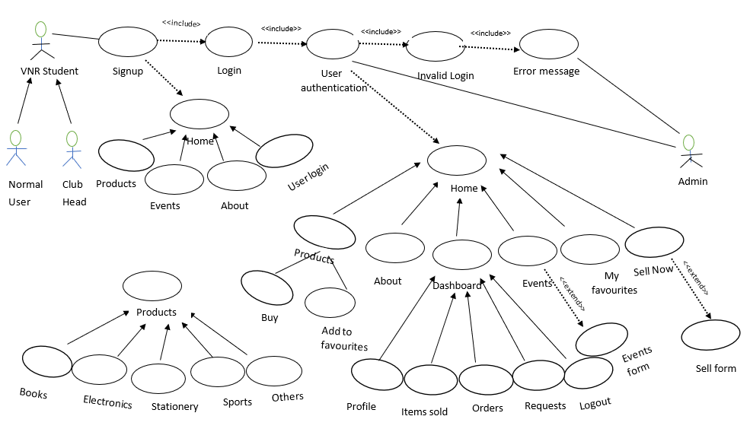

**Fig 5.1:** Use Case Diagram for Developed Model

20

# Class Diagram

They are static representation of an application. Only the class diagrams have the capability to be directly mapped with the OOP Languages because in OOPs everything is model in the form of classes and objects. Because of this reason these diagrams are used widely at the time of construction. It acts as a base for the component and deployment diagrams.

1. It mainly describes and defines the basic responsibilities of a system’s application.
2. It implements the analysis and design view for a static application.

In a class diagram, each object is modelled as a class. Each class consists of section or compartments.

* 1. Class name
  2. Attributes of a class or operations
  3. Methods or functions
  4. Documentation (optional section)

The following points ought to be recollected while drawing a class diagram:

1. The name of the class diagram must be meaningful to portray the aspect of the framework.
2. Each component and their connections must be distinguished ahead of time.
3. Each class has a responsibility that must be identified clearly.
4. Number of properties for each class must be minimum. Since pointless properties will make the diagram convoluted.
5. At whatever point required to depict some part of the diagram use notes Since toward the finish of the diagram it must be justifiable to the designer/coder.
6. Before finalising the last version, the diagram must be drawn on plain paper and revise whatever number circumstances as would be prudent to make it redress.

21

#### Scopes:

The UML diagrams have two different types of scopes forclass members:

* 1. instance members scope and
  2. classifier members scope

1. **Classifier members** are “static” members of a class in many programming languages. The scope is the class itself.
   1. Static attributes are common to all other objects that invoke the class. Static methods are not instantiated.
2. **Instance members** are nothing but the members that are local to an object.
   1. The main purpose of instance members is to allow the objects to store their states.
   2. Declarations outside the methods are usually known as instance members.

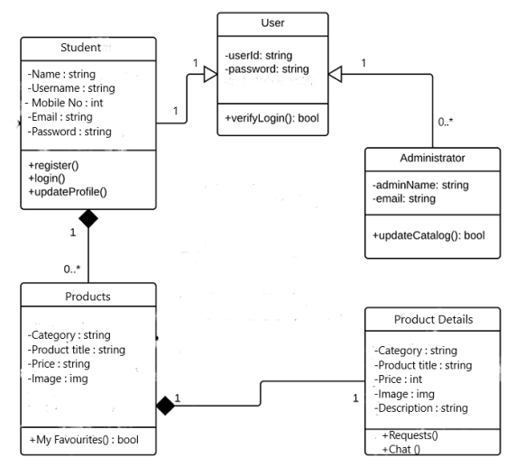

**Fig 5.2:** Class Diagram for Developed Model

22

* + 1. **Sequence diagram**

The Sequence Diagram depicts the time sequence among various objects in an application. It depicts the sequence of messages with which objects communicate with each other so that they carry out the required functionality.

### Common Properties:

An arrangement graph is much the same as unique sort of diagram and offers some indistinguishable properties from other diagrams.

### Contents

Objects are normally named or unknown instances of class, however may likewise speak to occurrences of different things, for example components, collaboration and nodes. Graphically, object is represented as a rectangle by underlying its name.

### Links

A link is a semantic association among objects i.e., an object of an affiliation is called as a connection. It is represented as a line.

### Messages

A message is a determination of a correspondence between objects that passes on the data with the desire that the action will follow.

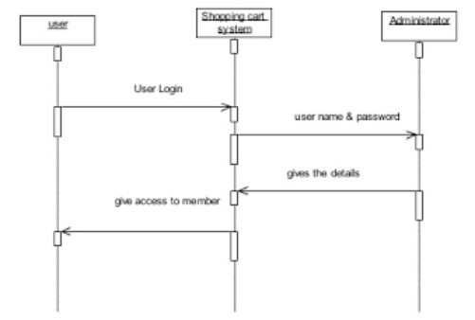

**Fig 5.3** Sequence Diagram for User registration

23

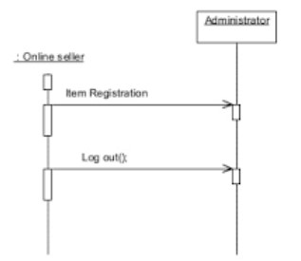

**Fig 5.4** Sequence diagram for Seller registration

# Activity Diagram

The flow from one activity to another activity can be represented in the form of a flow chart which is usually an activity diagram. It forms a backbone for the UML diagrams. It depicts the dynamic aspects for all the objects within the system.

Activity diagrams are constructed using the following:

1. Actions are represented using rounded rectangles;

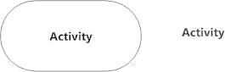

1. decisions are represented using diamonds;

24



1. concurrent activities bars are represented using the start (split) or end (join) ;

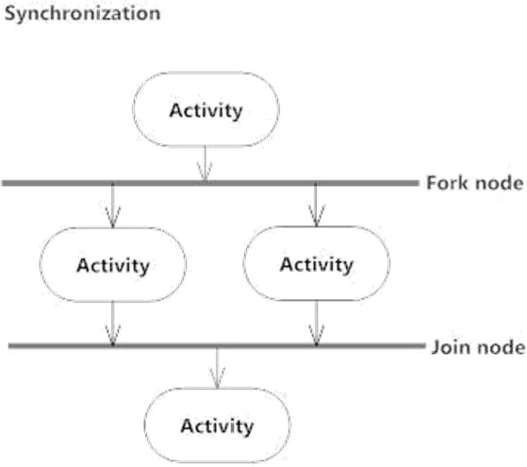

1. Time event is represented as



1. final state is represented using encircled black circle.



The basic purpose of an activity diagram is same as that of other UML diagrams. The dynamic behaviour of the system is viewed by the activity diagram. They are used to construct a system using the backward and forward engineering mechanisms.

The purpose of an activity diagram is as follows:

25

1. For drawing the flow (i.e. activity) in a system.
2. For showing the flow of sequence from one activity to another activity.
3. For showing the concurrent and parallel flow of actions in the system.The elements that are used in an activity diagram are as follows:

a) Association

b) Activities

c) Conditions and Constraints.

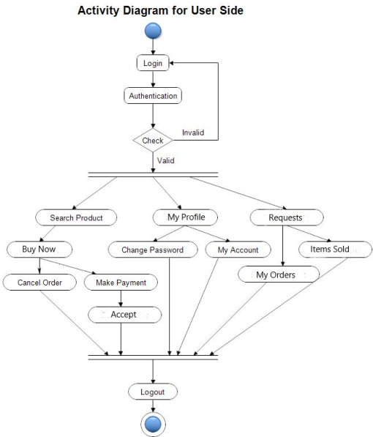

### Fig 5.5 Activity Diagram

26

# CHAPTER 6

# IMPLEMENTATION

# CODE

# Setting Up Virtual Environment and Installing Django

# Install and create a virtual environment and install Django in it which provides a light-weight server.

# Install packages such as pillow, passlib, psycopg2.

# 

# Fig 6.1: Virtual environment setup

# 

# Fig 6.2: Installing Packages

27

# Starting Project and Apps

# Follow the below commands as shown to create project and apps.

# 

# Fig 6.3: Project and apps creation

# 

# Fig 6.4: Running Django server

# Project folders

# The project folder name is “ADPOST” and the settings folder is “adpost”.

# The following code need to be included in the settings folder i.e., adpost before starting apps.

# 

# Fig 6.5: adpost – Installed Apps

28

# 

# Fig 6.6: adpost – static and assets folder

# 

# Fig 6.7: adpost – postgres connection

# The apps created inside the project folder are accounts, buysell, forms, pages.

# In the Fig 6.8, the “templates” folder contains all the templates and “manage.py” is the file that lets you interact with the Django project in various ways.

# 

# Fig 6.8: Project Folders

29

# 6.1.3.1 urls.py

# 

# Fig 6.9: adpost urls.py

# 

# Fig 6.10: accounts urls.py

# 

30

# Fig 6.11: buysell urls.py

# 

# Fig 6.12: pages urls.py

# 

# Fig 6.13: forms urls.py

# 6.1.3.2 Templates folder

# 

# Fig 6.14: Templates Folder

31

# 

# Fig 6.15: Navbar(1)

# 

# Fig 6.16: Navbar(2)

32

# Sample HTML Pages:

# 

# Fig 6.17: Login Form

# 

# Fig 6.18: Sample Product Page(Books)

33

# 

# Fig 6.19: Footer

# 

# Fig 6.20: Validation messages

# 6.1.3.3 views.py

# 

# Fig 6.21: Sample views function

34

# 6.1.3.4 models.py

# 

# Fig 6.22: Sample model class

# 6.1.3.5 Links

# All the below links are included.

# 

# Fig 6.23: Links

# 

35

## **6.2** **Performed Tasks**

Project name is Adposting website for buyer-seller interaction over purchase of used goods - CONNECT. An online platform on the Internet where buyers can browse the catalog and select products of interest and sellers can sell their products. The user can add his/her favourite products to ‘My favourites’. The seller and buyer can interact through the whatsapp chat option available. When the buyer and seller are okay with the deal, the seller then accepts the buyer request after which the item details are shown in the items sold, orders of buyer and seller respectively. Also, any head of clubs/organizations can post their events on connect.

### Web Pages details

1. Home Page
2. About Page
3. Product Pages
4. Events Page

5.My Favourites Page

1. User Dashboard
2. Sell Form
3. Event Registration Form
4. Sign Up Page

10.Login Page

# 6.2.1 Home Page

* The Buyer can choose products based on categories like Books, Electronic Gadgets, Stationery, Sports, Others.
* The person who wants to sell products can click on the “Sell Now” button which redirects to the Sell form.

36

* The details to be filled in the Sell form are Product category, Product title, Product description ,price, image.
* Few products of various categories are also displayed.

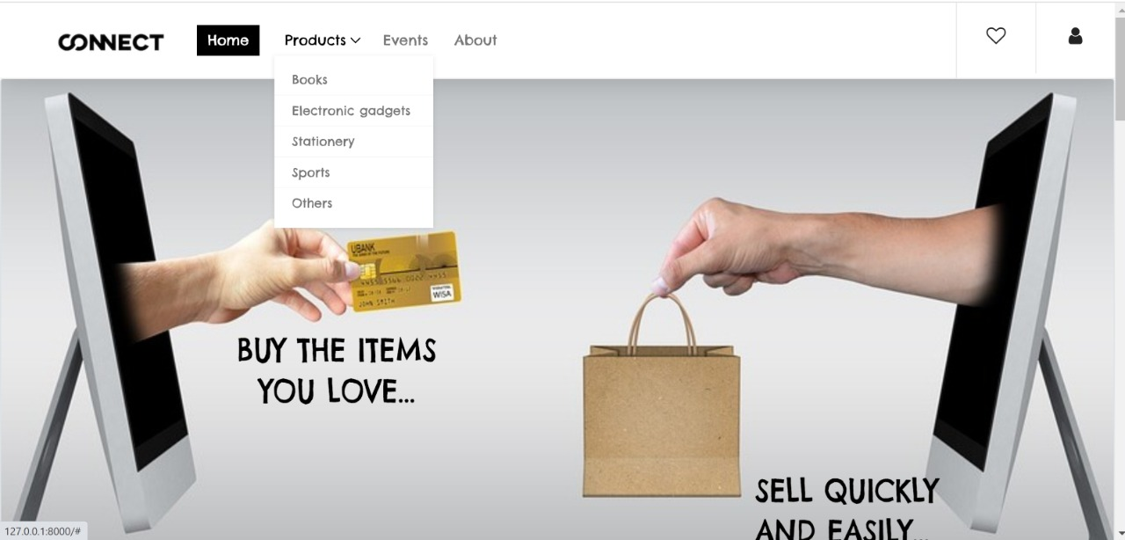

**Fig 6.24:** Home Page

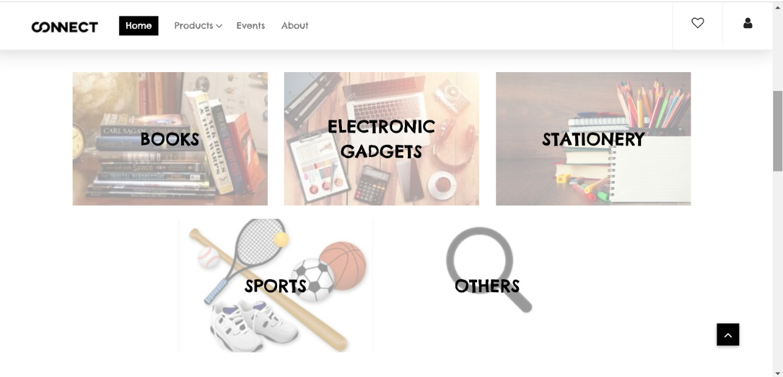

**Fig 6.25:** Home Page – Product ­Categories

37

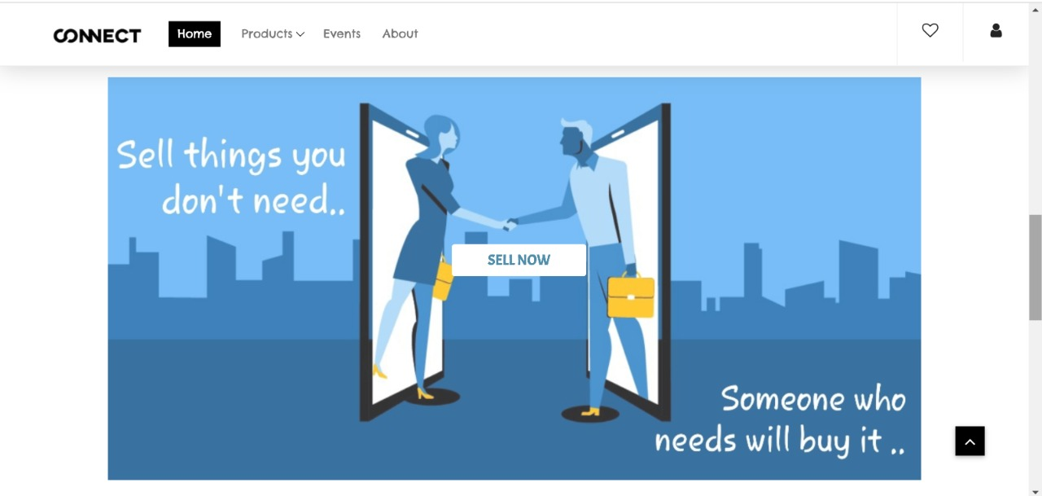

**Fig 6.26:** Home Page – Sell Now

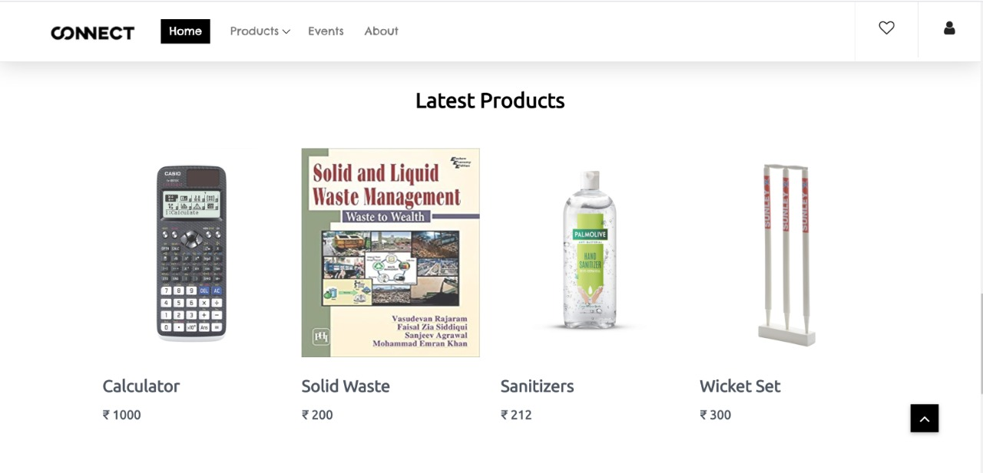

**Fig 6.27:** Home Page – Latest Products

# 6.2.2 About Page

* Location of the organization can be seen here.
* In case of any queries, users can contact the details provided.

38

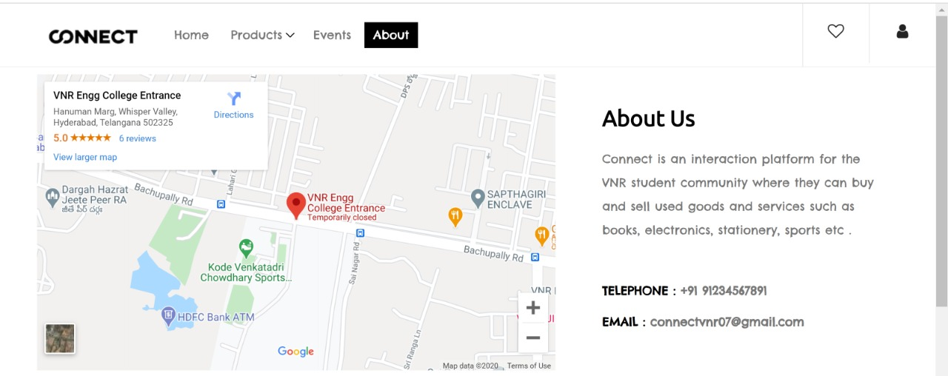

**Fig 6.28:** About Page

# 6.2.3 Products Page

* We have five product categories – Books, Electronics, Stationery, Sports, Others.
* In every category page, their respective product details are displayed in the form of cards.
* Every card has its own product image, product title, product price, Know More, buy now and favourite buttons.
* Each product’s description can be viewed by clicking on “Know More”.
* Whatsapp chat option is available in the respective product details page where the buyer can interact with the seller.
* Users can add their favourite products to “My Favourites” by either clicking on the favourite icon or “Add to My Favourites” button in the product details page.
* Buyers can send their requests to sellers by clicking on “Buy Now” button.

39

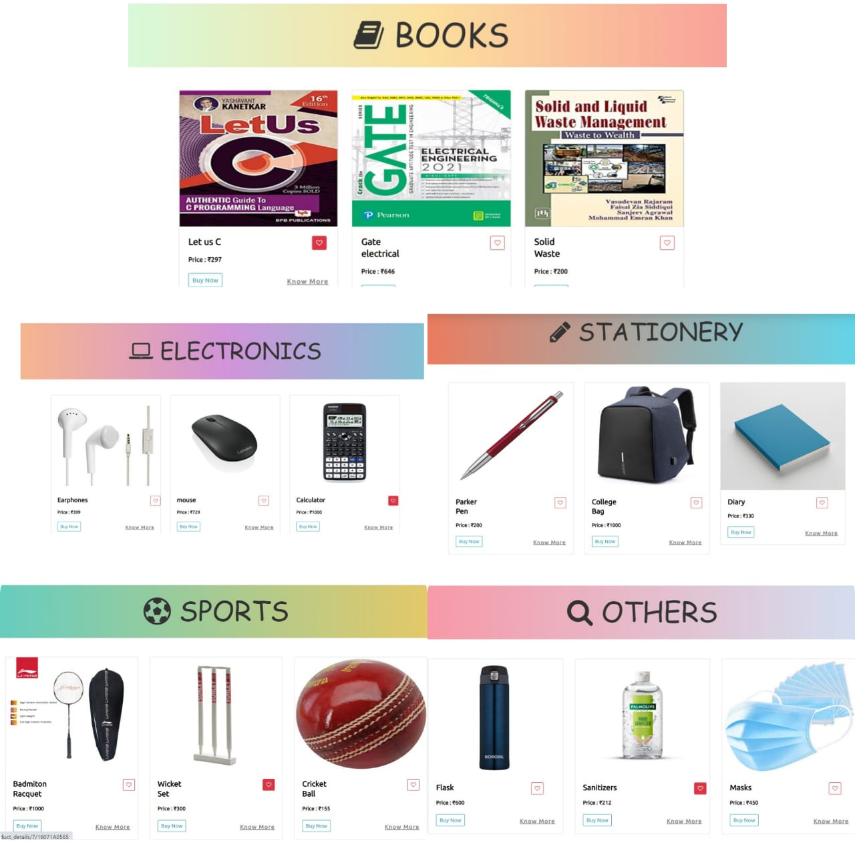

**Fig 6.29:** Product Category Pages

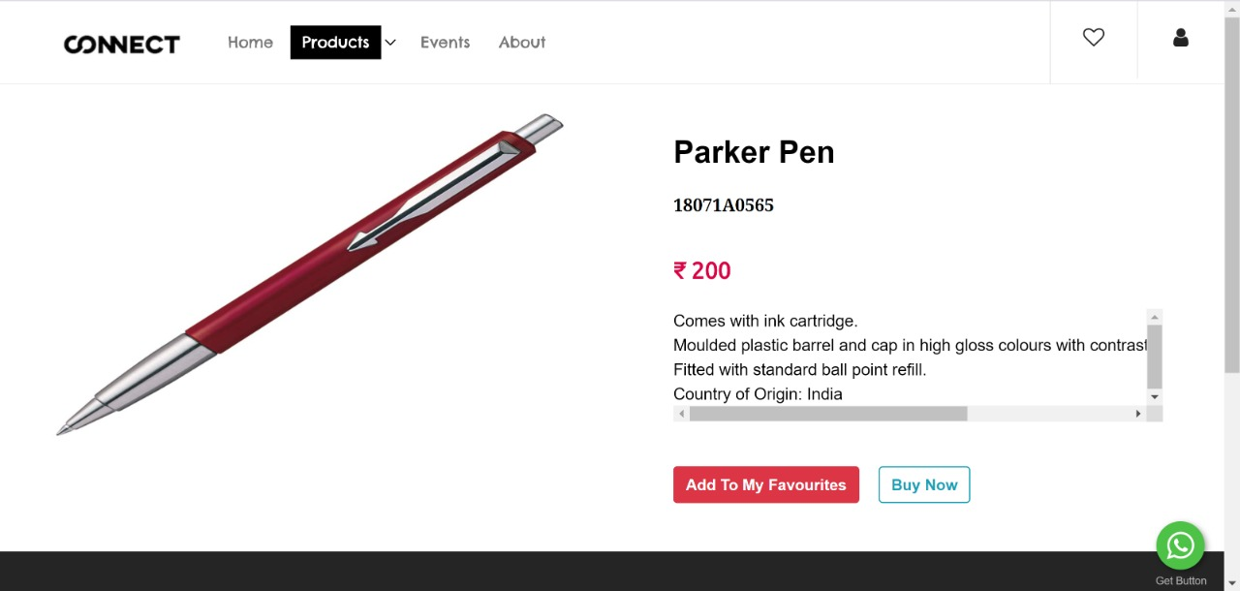

**Fig 6.30:** Product Details Page Example

40

# 6.2.4 Events Page

* Event details such as event image, event title, start-date, end-date, event link, venue, event description is displayed which have been posted by the clubs.
* The page has a button “Click Here” which redirects to Event registration form for those who want to post their events.

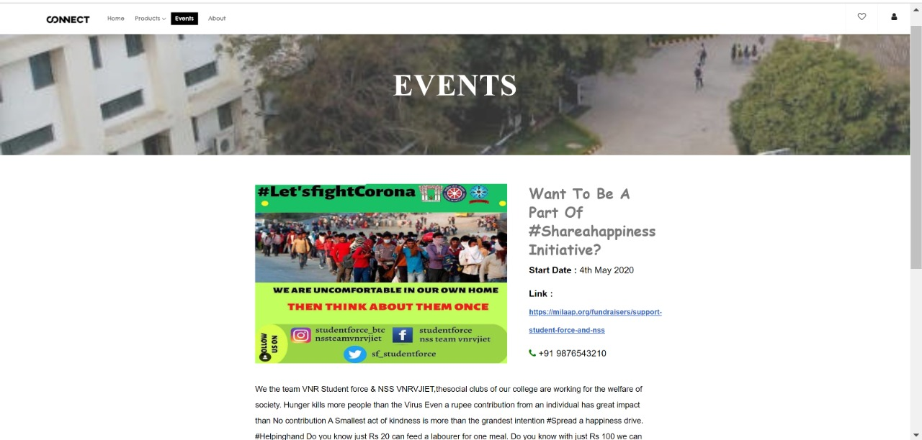

**Fig 6.31:** Events Page

# 6.2.5 My Favourites Page

* The user’s favourite products are displayed here.

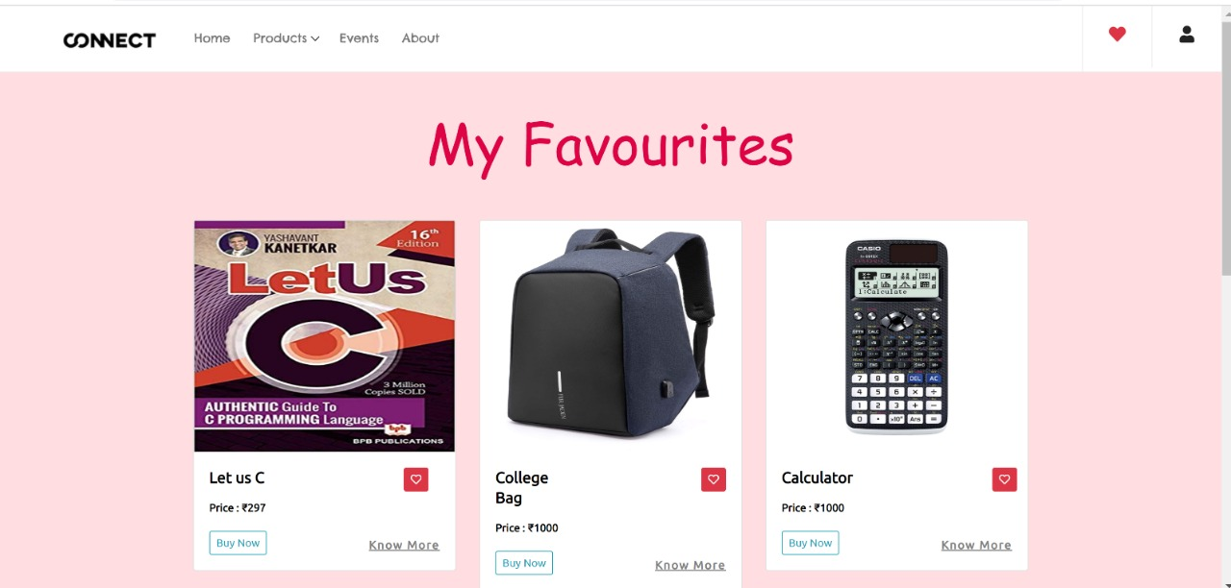

**Fig 6.32:** My Favourites Page

41

# 6.2.6 User Dashboard

* Users can login to their account by providing username(roll no) and password.
* After user gets logged in, a dashboard will appear that contains My profile,My Orders, Items sold, Requests ,Chat, Logout.
* New users should Sign-up by providing details such as fullname, username(roll no) , email , mobile number ,password.
* The username should be a valid rollno provided by that particular organization.

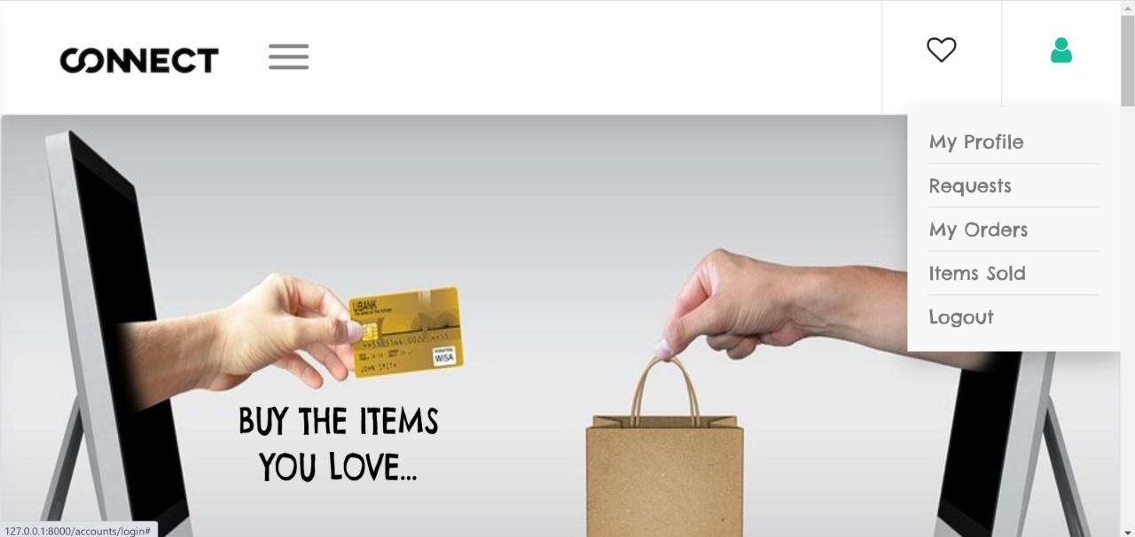

**Fig 6.33:** User Dashboard

# 6.2.6.1 My Profile

# The user details such as name, email, phone number, password (in encrypted format) are displayed.

# 

# Fig 6.34: User Profile

42

# The user can change his/her password by clicking on “Change Password”.

# 

# Fig 6.35: Change Password

# 6.2.6.2 Requests

# When the buyer clicks on “Buy Now” button, then a request is sent to that particular seller and is visible in the seller’s product request page.

# 

# Fig 6.36: Requests Page

43

# 6.2.6.3 Orders Page

# When the seller accepts the buyer request, then that product details are visible in the buyer’s Orders Page.

# 

# Fig 6.37: Orders Page

# 6.2.6.4 Items Sold

# When the seller accepts the buyer request, then that product details are also visible in the seller’s Items Sold Page.

# 

# Fig 6.38: Items Sold

44

# 6.2.7 Sell Form

# The seller needs to fill in this form by providing details such as product category, product title, product description, product image, product price.

# 

# Fig 6.39: Sell Form

# 6.2.8 Event Registration Form

# The club heads need to fill in this form by providing details such as username, event name, event description, contact number, start date, end date, venue, event link, event images.

# 

# Fig 6.40: Event Registration Form

45

# 6.2.9 Sign Up Page

# The student who wants to register in the website needs to provide his/her valid organization roll number as username, full name, email, mobile number, password.

# 

# Fig 6.41: Sign Up Page

# 

# 6.2.10 Login Page

# The user has to provide valid credentials and get authenticated in order to get logged in.

# 

# Fig 6.42: Login Page

46

# CHAPTER 7 TESTING

# TESTING PLAN

Testing process starts with a test plan. This plan identifies all the testing related activities that must be performed and specifies the schedules, allocates the resources, and specified guidelines for testing. During the testing of the unit the specified test cases are executed and the actual result compared with expected output. The final output of the testing phase is the test report and the error report.

# Test Data

Testing process begins with a test design. This arrangement recognizes all the testing related exercises that must be performed like the timetables, assigning the assets, and determining rules for testing. This testing of the unit of the predetermined experiments are executed and the genuine outcome is expected. The last part of the testing stage is the test report and the error report.

# Testing Methods

# 7.1.2.1 Blackbox Testing

# Black box testing, also known as Behavioral Testing, is a software testing method in which the internal structure/design/implementation of the item being tested is not known to the tester.

# These tests can be functional or non-functional, though usually functional.

# Fig 7.1: Blackbox Testing

47

# 7.1.2.2 White box Testing

# White Box Testing is software testing technique in which internal structure, design and coding of software are tested to verify flow of input-output and to improve design, usability and security.

# In white box testing, code is visible to testers so it is also called Clear box testing, Open box testing, Transparent box testing, Code-based testing and Glass box testing.

# 

# Fig 7.2: White box Testing

# Unit testing

Every individual module has been tried against the necessity by considering the following cases:

* When a person wants to buy or sell a product, then his/her details are validated with organization’s database.
* When a person wants to post an event, then his/her details are validated with the organization and club’s database.

# Test Report

The module is working appropriately given the client must enter data. All information section frames have tested with indicated test cases and all information passage shapes are working properly.

48

# Error Report

On the off chance that the client does not enter information in determined request, at that point the client will be incited with error messages. Error reduction is done to deal with the normal and sudden mistakes.

49

# CHAPTER 8

# Conclusion

# Conclusion

# Website is user friendly (can be opened in any device of any width-responsive) and it serves as a platform where the students can sell their used products when not required to other students who are in need.

# Students will get to know about the upcoming event details through our platform and as we limited the access of our website to an organization, there will be less chance of frauds and can be resolved easily if any.

# Future Scope

1) Implementing inbuilt chat.

2) Notifications about the events.

3) Generating personalized information using ML and AI.

4) Offering discounts using analytics.

5) Developing the 'Connect' app.

6)Extending ‘Connect to various organizations.

50

# CHAPTER - 9

## **BIBILIOGRAPHY/REFERENCES**

## **9.1 References**

## https://docs.djangoproject.com/en/3.1/

1. <https://getbootstrap.com/docs/4.0/getting-started/introduction/>
2. https://developer.mozilla.org/en-US/
3. https://fontawesome.com/
4. https://fonts.google.com/
5. https://stackoverflow.com/
6. <http://uigradients.com/>
7. https://colorlib.com/wp/templates/

51